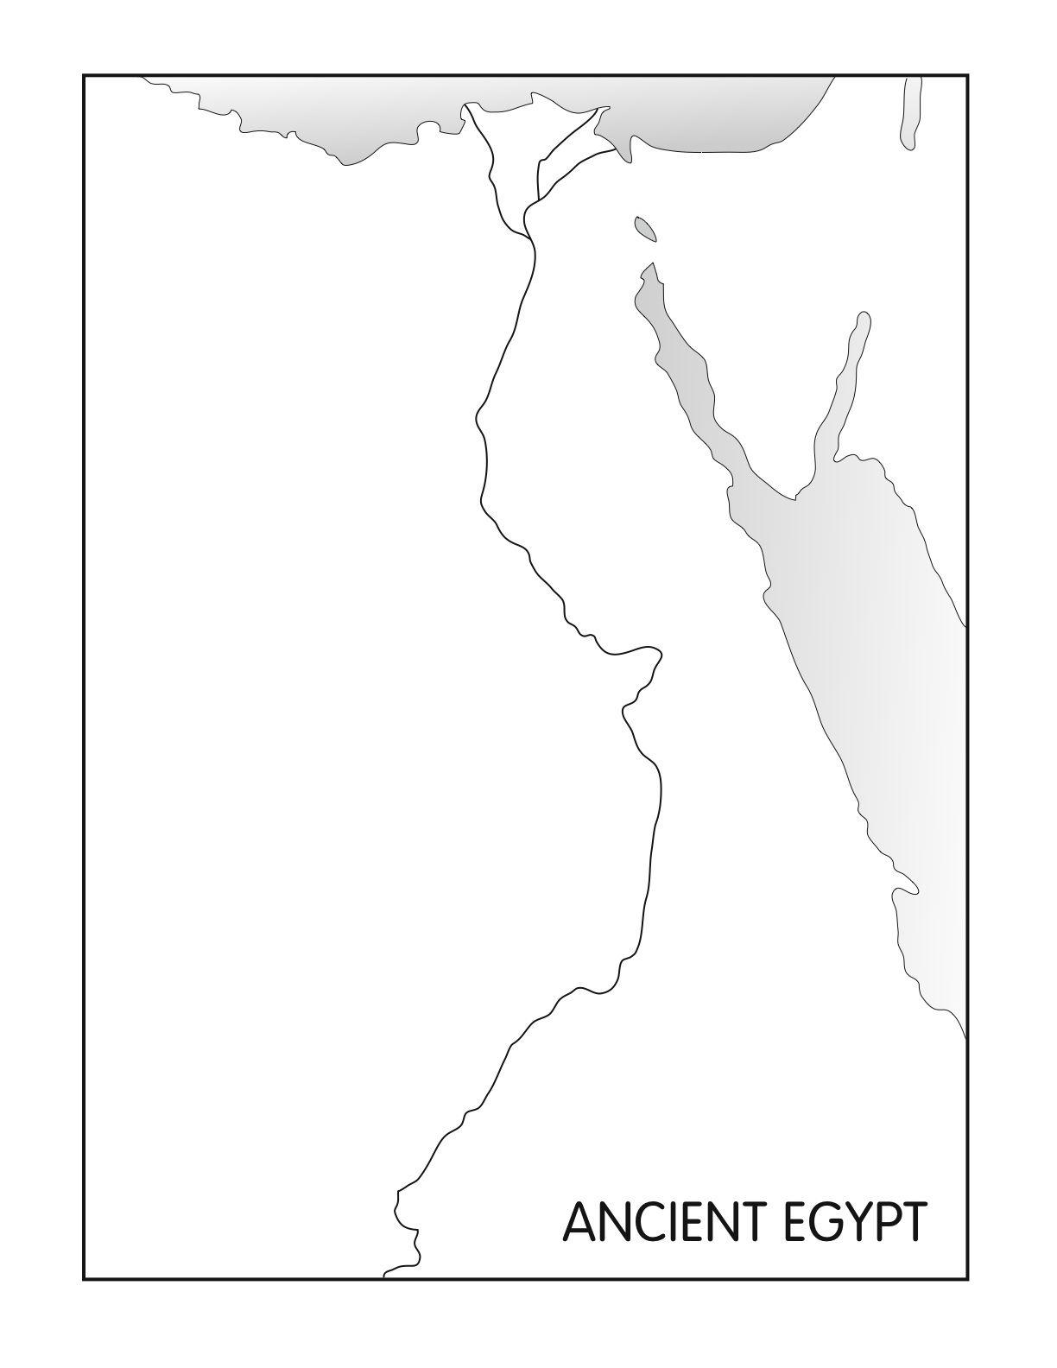
Your Task:
Using the information on p. 579 in your textbook to label the map. Be sure to include the following information:
-Upper and lower Egypt
Nubia
-Desert and fertile land (use different coloured pencils to label this)
-The Nile River
-A key (to show north, south, east, west)
-The Red Sea and Mediterranean Sea
-The Gulf of Suez
-All cities and bordering countries
-Libyan Desert and Arabian Desert

